The Roundhouse Floor History

BB Season | Center Court Description | Lanes/End Line  Description | Documentation Reference
1984-85 | No logo at centercourt | Plain | Team Photo from 1985 yearbook
1985-86 | Bullpup Head  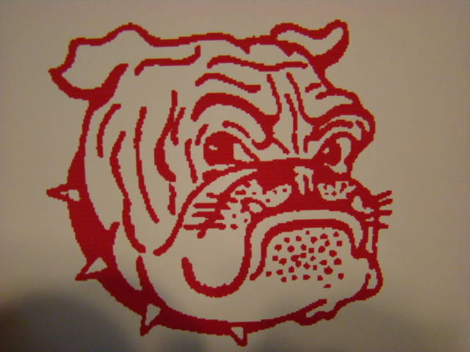 | Plain | Team Photo from 1986 Yearbook
1989-90 | Bullpup Head | Plain | Picture in Salina Journal of Coaches Frazier, Randle, & Henson 11-28-89
1994-95 | Bullpup Head | Plain | From '95 yearbook
1995-96 | Bullpup Head | Plain | From '96 yearbook
1996-97 | Bullpup Head with legs | Plain | p.145 from '97 yearbook
1997-98 | Bullpup Head with legs | Plain | p.74 from '98 yearbook
1998-99 | Bullpup Head with legs | Plain | 2-5-99 MH photo
2003-04 | Bullpup Head with legs | Plain | Photo from Rusty's visit, old bleachers
2004-05 | Bullpup Head with legs | Plain | New bleachers  p. 142,76,85,88,89,93,115
BB Season | Center Court Description | Lanes/End Line  Description | Documentation Reference
2005-06 | Bullpup Head with legs | Plain | 2006 yearbook picture  p.38 Individual ceiling tiles and conical lights indicate the old ceiling is in place.
2006-07 | Bullpup Head with legs  p.100 unpainted lanes  p.142 view of old logo  p. 75 new bleachers  p. 90,102,105 new lights | Plain | Last Season for the original floor. Dec. '07 Christmas boards for the kids. New Lights.
2007-08 | Red Letter "M" | Filled in lanes & end lines | 1st year of new floor,  2008 yearbook pictures
2008-15 | Red Letter "M" | Filled in lanes & end lines | Yearbook pictures

Mike Rausch 241-4250
Carol Swenson 241-5452
Marty Sigwing

Revised: 3/1/2015

